SM302/SM302-EX
SPECTRA
Version G

(SP Document #1080523)
Copyright 1995, Spectral Products LLC

NOTICES

General:
This manual and the software it describes are provided free of charge as a service to the customer. The software is intended to be used as a tool for development and as an example of one possible method of code implementation.

Copyright:
SP maintains the copyright on this material, but grants the customer rights to use or modify the software described herein without obtaining SP’s permission and without the requirement to reference SP as the source of material.

Warranty:
This manual and the software described herein are provided “as is” with no warranty, expressed or implied.
While it is Spectral Products LLC’s intent to provide error-free useful development tools, no guarantee is made regarding the accuracy or ultimate usefulness of this material. SP reserves the right, without prior or further notice, to make changes to any of its products described or referred to herein to improve reliability, function, or design.

Liability:
SP accepts no liability for incidental or consequential damages arising from the use of this software.

Spectral Products LLC does not recommend the use of its components or software products in life support applications wherein a malfunction or failure of the product may directly threaten life or result in injury.

LabView® is a registered trademark of National Instruments.

TABLE of contents
1. Introduction 4
2. Installation 5
2.1. Checking System Requirements 5
2.1.1. Requirements for the Hardware 5
2.1.2. Requirements for the Software 5
2.2. Checking System Package Contents 5
2.3. Installing the SM302 System 6
2.4. Installing the Software 6
2.4.1. Installing the LabVIEW run time setup disks 6
2.4.2. Installing the SM302 setup disk 6
3. Getting Started 7
3.1. Using the Mouse and Drop-down Menu 7
3.1.1. The Mouse 7
3.1.2. The Drop-down Menu 7
3.2. Menus, Tool Bar, Controls and Indicators 7
3.2.1. Menus 7
3.2.1.1. File Menu 7
3.2.1.2. Edit Menu 8
3.2.1.3. CCD Menu 8
3.2.1.4. Windows Menu 9
3.2.1.5. Format Menu 9
3.2.1.6. CM110 Menu 9
3.2.1.7. Help Menu 10
3.2.2. Toolbar 10
3.2.2.1. Description 10
3.2.2.2. Running VI 10
3.2.3. Controls and Indicators 11
3.2.3.1. Graph Control 12
3.2.3.2. Data Collection Options 13
3.2.3.3. Auto-Calibrate Procedure 14
3.2.3.4. Detector Setup 15
3.2.3.5. Miscellaneous 16
4. Appendices 17
4.1. Appendix A - Novram Locations 17
4.2. Appendix B - Wavelength Ranges 18
4.3. Appendix C - Serial Port & GPIB Error Codes 19
4.4. Appendix C – GPIB-232CV-A 20

1. Introduction

The SM302 software provides an interface between a monochromator and a linear image sensor. The SM302 system consists of a CM110 monochromator and an AD302-cooled InGaAs detector.
The software was written mainly in LabVIEW version 6i for Windows. For fastest image display, it is recommended that you have a minimum of 32MB of RAM in your computer. LabVIEW can run on an 80486-based PC, but we strongly recommend a computer with a Pentium CPU.

2. Installation

Refer to the CM110 and InGaAs C7221/C8061/C8062 user manuals for proper power and communications, as well as any other pertinent installation information. The default setting for the CM110 communication port is COM1.

2.1. Checking System Requirements
Check to make sure that your computer meets the minimum requirements for the CM&InGaAs system.

2.1.1. Requirements for the Hardware
- 1 communication port.
- 1 PCI slot.
- A mouse or any other pointing device.
- A VGA, SVGA display, or 1024x768.

2.1.2. Requirements for the Software
- Any IBM compatible machine with a Pentium processor.
- A hard disk with at least 10MB free space, and 7MB is needed for installation.
- A CD drive.
- Microsoft Windows version 95 or newer in standard or enhanced mode.
- Minimum of 32 MB of RAM recommended.

2.2. Checking System Package Contents
Check to make sure that your package contains all the following components. The CM&InGaAs system consists of:
- SM302/SM302-EX unit.
- 1 SM302/AD302 Power supply.
- NI-DAQ 6052E card.
- 1 DK12V10 CM110 power supply.
- 1 Standard RS-232 cable (9 to 9 D sub)
- 1 68-pin to 68-pin cable that connects from NI-DAQ 6052E card to 68-pin DAQ Control on AD302/SM302 power supply.
- 1 15-pin to 15-pin cable that connects from AD302/SM302 power supply to Signal I/O on the detector head.
- 1 9-pin to 9-pin cable that connects from AD302/SM302 power supply to TE Control I/O on the detector head.
- 1 CD for CM&InGaAs software. In addition, you can get this run time setup at ftp://ftp.natinst.com/support/labview/runtime/windows/6.0/
- 1 user manual for CM110.
- 2 CDs for NI-DAQ driver software.

2.3. Installing the SM302 System
Before making any connections between a computer and the SM302, all of the devices should be off. For cable connections, refer to section 2.2 for cables.
- Install NI-DAQ acquisition card into computer.
- Connect the cable with four terminals to its positions.
- Connect the standard RS232 cable from a computer serial port to "RS-232" connector on the SM302.
- Connect the DK12V10 power cable to the “Power” connector.

2.4. Installing the Software
There are three floppy disks for the SM302 software: two for LabVIEW run time setup files, and one for CM&InGaAs setup files or only one CD for all.

2.4.1. Installing the LabVIEW run time setup disks
- Insert the first disk or CD into a disk or CD drive.
- Run Setup.exe and follow the instruction on screen to finish the installation of the LabVIEW run time.

2.4.2. Installing the SM302 setup disk
- Insert the disk or CD into a disk or CD drive.
- Run Setup.exe and finish the installation.

3. Getting Started

Once the SM302 software has been installed, you are ready to get started.

3.1. Using the Mouse and Drop-down Menu

3.1.1. The Mouse
The mechanics of using a mouse with the SM302 software conforms to the Microsoft Windows standard. The following conventions are used in the manual when explaining manipulations with the mouse: “Clicking” the mouse on an object consists of moving the mouse cursor until it is pointing to the object and depressing the specified mouse button once or twice in quick succession. If you have reconfigured your mouse for other-handed use, switch the references (specified or assumed) to the right and left buttons.

3.1.2. The Drop-down Menu
Menu options are referenced as “to level menu”: “submenu option” like these following examples:
File
Open… is referenced as File:Open…

Help
Show Help is referenced as Help: Show Help

3.2. Menus, Tool Bar, Controls and Indicators
This section has detailed descriptions about the menus, tool bar, controls and indicators. For each menu, a brief description of each command is given. In addition, LabVIEW programs are called virtual instruments (VIs).

3.2.1. Menus

3.2.1.1. File Menu
- Open. Opens an existing VI. A status dialog is displayed while that VI is opening. This status dialog identifies the VIs that are currently being loaded and gives you an opportunity to cancel the load process.
- Close. Closes the active window and does not save any changes you have made.
- Printer Setup… Sets configuration options for the printer. You can change the orientation of printout (landscape versus portrait). Printer Setup settings are saved with your VI.
- Print Window… Prints out the contents of the currently active window. Using this option, you can make a quick printout with the minimum number of prompts.
- Calibrate. Calibrates pixels to nanometers. To calibrate fill in the table with two columns: pixel and lambda. Minimum three data points are needed.
- TableP2L. Displays all 256 pixels vs wavelength in nanometers based on the current calibration.
- L2Px. Calculates the pixel number with a given wavelength based on the current calibration.
- Exit. Quits LabVIEW.

3.2.1.2. Edit Menu
- Preferences… Sets preferences for memory, disk, and display.
- Print at Completion. Prints the contents of the front panel any time the VI completes execution.
- Log at Completion. Logs a time stamp and the data in all front panel controls of a VI to a separate datalog file.
- Data Logging. Displays data logging options. (Optional if you have LabVIEW software).
- Reinitialize All To Default. Sets all controls and indicators to their default values.

3.2.1.3. CCD Menu
- CCD temp. Shows the current InGaAs detector temperature.
- ADC Info. Displays the A to D gain table.
- Bad Pixels. Displays the Select Bad Pixels.vi
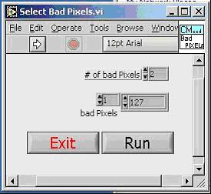
# of bad Pixels – is the total number of pixels that will be binned to the next pixels.
Bad Pixels – are the location of the bad pixels.
Run – sets the bad pixels into memory.
Exit – closes the Select Bad Pixels.vi

For example – there are three bad pixels at locations: 80, 127, and 198. The numbers have to entered as follows:

, 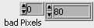, 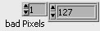, 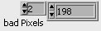

3.2.1.4. Windows Menu
- Show VI Info... Displays the VI file path, revision number, and memory usage.
- Full Size. Uses the entire screen to display the active window.

Format Menu
- Pixels. If the option is selected, the unit of x-axis will be in pixels for the next collect new scan.
- nm. If the option is selected, the unit of x-axis will be in nanometers for the next collect new scan.

CM110 Menu
- Echo. Displays the Echo VI, which is used to verify communications with the CM monochromator.
- Flush. Displays the Flush VI, which is used to read all RS232 input buffers associated with port number.
- Goto. Displays the Goto VI, which moves the monochromator to a selected position. Valid values of position are grating dependent and are describe in Appendix B.
- Query. Displays the Query VI, which is used to query twenty-one status messages from monochromator Novram IC. The meaning of the messages is in the Appendix A.
- Reset. Displays the Reset VI, which is used to reset monochromator to home position.
- Select. Displays the Select VI, which is used to select the grating will be operated.
- Size. Displays the Size VI, which is used to determine the change in magnitude and direction of the monochromator's position after a STEP command.
- Units. Displays the Units VI, which is used to select the unit applied in the GOTO, SCAN, SIZE, and CALIBRATE commands.
- Inc. Displays the Inc VI, which is used to increase the zero offset value and change the grating angle by 0.0075 degrees in the CCW direction. This is generally always followed by the ZERO command. The monochromator does not track the change in wavelength incurred by this command. The new offset is not in effect unless the ZERO command is issued.
- Dec. Displays the Dec VI, which is used to decrease the zero offset value and change the grating angle by 0.0075 degrees in the CW direction. This is generally always followed by the ZERO command. The monochromator does not track the change in wavelength incurred by this command. The new offset is not in effect unless the ZERO command is issued.
- Zero. Displays the Zero VI, which is used to recalibrate of the position of the zero order transmission of the monochromator. The monochromator should be set to pixel number 127 at the peak of the zero order transmission for each grating while using INC and DEC, the ZERO command is entered.
- ActivateCM. Displays wavelength, unit box, and ‘SET’ button. The wavelength box shows the current wavelength of the monochromator, and a user can set to a different wavelength by using the box and SET button. The unit box displays the current unit.
- SET. Sets the monochromator to the wavelength that entered in CM wavelength box.

3.2.1.7. Help Menu
- Show Help. Is a Context-sensitive Help window that displays a function’s or VI’s parameters, parameter type definitions, and the description for the object.
- About. Information on LabVIEW software version number and serial number.

3.2.2. Toolbar

3.2.2.1. Description
The LabVIEW toolbar contains four command buttons as in figure 1.

Fig. 1. LabVIEW Toolbar
Run button. Runs the VI.


Continuous run button. Runs the VI over and over.


Stop button. Aborts VI execution.

Pause/Continue button. Pauses VI execution/Continue VI execution.

3.2.2.2. Running VI
You can run a VI by selecting Operate:Run or clicking on the run button.


While the VI is executing, the run button changes appearance. If the VI is running at its top level, the run button looks like the illustration shown to the left.

If the VI is executing as a sub VI, the run button changes to look like the illustration shown to the left.


The Return to Caller button appear when a suspended sub VI is not executing. Click it to return to the caller VI. Notice you can return to a caller without executing the current VI. If you want to execute it, be sure to press the Run button before returning to the caller.


The Skip to Beginning button will make the VI go back to the beginning.

3.2.3. Controls and Indicators
The main program of SM302 software is “CmInGaAs Vx.xx.VI” as shown in figure 1.
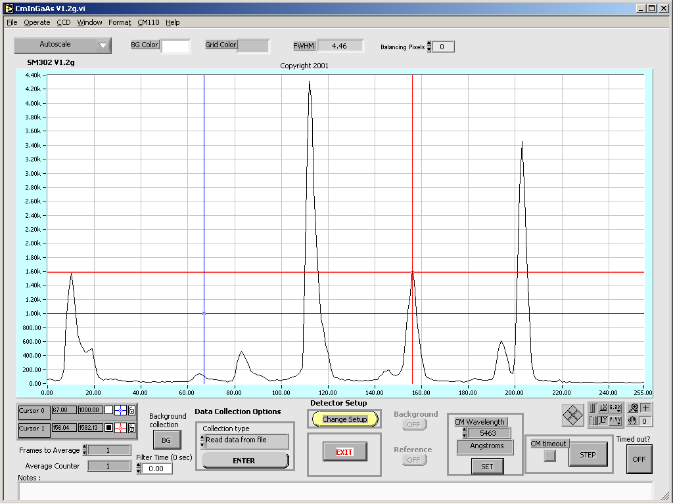
Fig. 1. Main Screen
In the main screen, there are graph, graph control, data collection options, detector setup, background, reference, frames to average, average counter, BG background collection, CM timeout, step, time out?, notes, autoscale control, BG color, grid color, and FWHM.

3.2.3.1. Graph Control
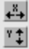
AutoScale (X or Y) - turns autoscaling on or off. If pressing the X AutoScale button, shown at the left, the graph AutoScale the x-axis. If pressing the y AutoScale button, the graph AutoScale the y-axis.
Lock Scale - clicking the lock switch, the graph will continuously autoscale.

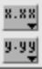
Scale Format - maintains run-time control of the format of the x and y scale markers respectively.


In standard operate mode, the plus or crosshatch is indicated. In operate mode, you can click in the graph to move cursors around.


Panning Tool - switches to a mode in which you can scroll the visible data by clicking and dragging the plot area of the graph.

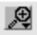
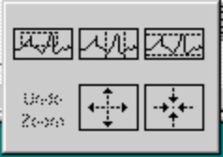
Zoom Tool - Zooms in or out on the graph. Clicking the zoom tool, you see a pop-up menu to choose methods of zooming. This menu is shown in the following illustration.

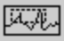
Zoom by rectangle.

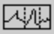
Zoom by rectangle, with zooming restricted to x data (the y scale remains unchanged)

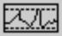
Zoom by rectangle, with zooming restricted to y data (the x scale remains unchanged)

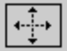
Zoom in about a point. If you hold down the mouse on a specific point, the graph continuously zooms in until you release the mouse button.

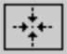
Zoom out about a point. If you hold down the mouse on a specific point, the graph continuously zooms out until you release the mouse button.


Cursor movement control.
Cursor name
X position
Y position
Select button for cursor movement.
Cursor display control
Lock control

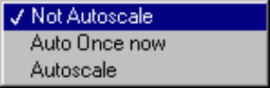
The control to fit Y scale to data: Not autoscale, Autoscale once now, and Autoscale.

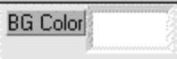
Control the background color for plotting surface.

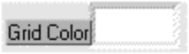
Control the grid color.

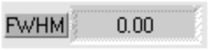
The Full Width at Haft Maximum of the highest bell shape on the graph.

Number of pixels to average. ‘0’ will do no averaging. ‘1’ with average each pixel with one to right and one to the left. The balancing pixels make the graph look smoother.

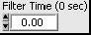
is the time constant in seconds for the image filter. This is a recursive digital filter that approximates a first order low pass filter.

3.2.3.2. Data Collection Options
There are seven options: Single, Continuous, Collect background, Collect reference, %Transmission, Write display to file, and Read data from file. In order to activate one of the options, you have to do two steps. First, select the collection type. Second, click on ENTER button.
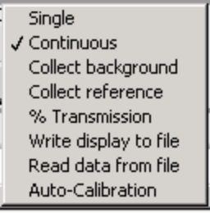

Single - is a single scan that acquires one new 256 data set using the defined number of Frame to Average, cooler state on/off, integration period, background on/off, and serial port. Then, the data is displayed on the screen.

Continuous - is the same as Single scan except that scans are repeated and the data are displayed continuously on screen until you select the other data collection option.
Collect background - is the same as Single scan except the data are temporarily stored in a background array that is used for background subtraction in Single, Continuous, Collect reference, and % Transmission scan. Once you collect the background, the background button will be active, but it is in off position. In order to use the background, you have to turn this background button on by clicking on it.
Collect reference - is the same as Collect background, but the data are temporarily stored in a reference array. In order to use the reference data, you have to turn this reference button on by clicking on it. In addition, you can activate the reference by collecting reference option.

% Transmission - is the same as Continuous scan except the data displayed on the screen were calculated based on
1. Background on: [(Signal - Background) / (Reference-Background)] * 100%
2. Background off: [(Signal) / (Reference)] * 100%
Write display to file - saves the current x, y data on the screen into 'x tab y' format file.
Read data from file – Displays data from a file to the graph.
Auto-Calibration – Automatically calibrate the wavelength axis of the spectral curves. To use the feature, refer to Auto-Calibrate Procedure.

Auto-Calibrate Procedure
Auto-Calibrate automatically finds the peak pixel on the graph, then uses the CCD pixel as the one adjustable parameter during the auto-calibration scanning procedure. The calibration from this method will not be as accurate as the multipoint calibration.
- Position a known spectral line near the center of the InGaAs array. This line must be the highest peak in the field of view. Enter the wavelength for this line in the CM Wavelength box, then click the Set button to position the monochromator to this wavelength.
- Select Auto-Calibration option, then click Collect new scan button. The software will position the grating to three different wavelengths. When this step is completed, the parameters for auto-calibration are created. The x-axis will display the current format that is selected from the Format drop-down menu.
- If the Auto-Calibration is successful, the x-axis will be able to display in nanometers, angstroms, or centi-microns, depending on the current unit of the CM monochromator. In nm-1Point format the x-axis can display the current setting wavelength and also adjust to the new wavelength setting.

Detector Setup

Click on the 'Change Setup' button to get the setup.vi as in figure 2.
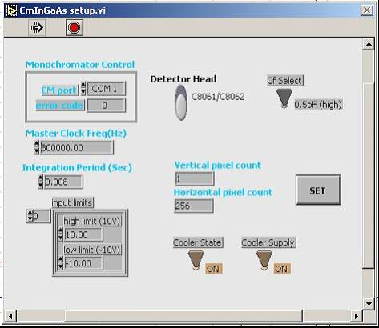

Fig. 2. Setup Screen

CM Port - is a serial COM port ( COM 1 to COM 9) that will be connected to the CM monochromator.
Error code - is -1 if baud rate, data bits, parity, or port number are out of range, or if the serial port could not be initiated. See Appendix C for the Serial Port Error Codes.
Master Clock Freq(Hz) - is the desired repetition rate of the continuous pulse train. The maximum clock is 800000.00 Hz
Integration Period (Sec) - is the period of the pulse train. The minimum value is 0.003 seconds.
Input limits - determine range, polarity and gain. It contains the following parameters:
- High limit - specifies the maximum input value of a channel. +10.00v for PCI-6052E card, and +5.00v for PCMCIA-16XE-50 card.
- Low limit - specifies the minimum input value of a channel. -10.00v for PCI-6052E card, and -5.00v for PCMCIA-16XE-50 card.
Cooler State - turns on/off thermoelectric cooler.
SET - sets all parameters and closes the setup.vi

3.2.3.5. Miscellaneous
Frame to Average - is the number of frames that will be averaged.
Average Counter - shows the current frame number being averaged.
CM Wavelength - shows the current wavelength of the CM monochromator. This box will be visible if you use ActivateCM, Goto.vi, Select.vi in CM110 drop-down menu, or nm in Format drop-down menu.
Exit - exits the CmInGaAs Vx.xx.vi
BG (Background Collection) – is the same as ‘Collect background’ in ‘Data collection option’, but it is quicker to access. You can use this BG to collect background data while background gray button is on.
Background - is a gray button. It will be active after you Collect background scan. In order to turn on the background, you can click on the button.
Reference - is a gray button. It will be active after you Collect reference scan. In order to turn on the reference, you can click on the button.
CM timeout - the default is gray. It will be red if an error has occurred on the communications line with the CM monochromator.
STEP - moves the monochromator by a preset amount defined by the SIZE command.
Timed out? - the default is OFF. It will be red and ON when the operation could not complete within the time limit.

4. Appendices

4.1. Appendix A - Novram Locations

Address | QUERY | STATUS MESSAGE
0 | Position | Current wavelength in current units.
1 | Type | 0: Single, 1: Additive, 254: Subtractive.
2 | Groove/mm | Current grating ruling (g/mm).
3 | Blaze (nm) | Current grating blaze wavelength (nm).
4 | Current grating | Number of grating currently being used (1-2).
5 | Scan speed | current scan speed in Å/sec.
6 | Step size | current size in current units.
7 | Zero Off.m1g1 | zero offset of machine 1, grating 1.
8 | Zero Off.m1g2 | zero offset of machine 1, grating 2.
9 | Zero Off.m2g1 | zero offset of machine 2, grating 1.
10 | Zero Off.m2g2 | zero offset of machine 2, grating 2.
11 | Cal. m1g1 | Calibration number of machine 1, grating 1.
12 | Cal. m1g2 | Calibration number of machine1, grating 2.
13 | # of grating | number of gratings installed in machine 1.
14 | Current units | 0: centi-Microns, 1: Nanometers, 2: Angstroms.
15 | Gr/mm m1g1 | grating ruling of machine 1, grating 1.
16 | Blaze m1g1 | grating blaze of machine 1, grating 1.
17 | Gr/mm m1g2 | grating ruling of machine 1, grating 2.
18 | Blaze m1g2 | grating blaze of machine 1, grating 2.
19 | Serial number | Monochromator’s serial number.
20 | Novram #14 | Not used.

4.2. Appendix B - Wavelength Ranges
The CM110/112 is restricted to angles between 0 and 70 degrees. The upper restriction is imposed because the grating is almost edge-on to the incident beam beyond this angle.
From these restrictions, one may use the grating equations to calculate the valid ranges and step sizes for any particular grating. The table below lists the maximum wavelength for each grating set in the CM110/112’s software.

Upper wavelength scan limit AND MAXIMUM WAVELENGTH
INCREMENTS PER ANGULAR STEP FOR DIFFERENT GRATINGS
(Lower wavelength scan limit is zero)

Grating Upper limit
Grv/mm | nm
3600 | 500
2400 | 750
1800 | 1000
1200 | 1500
600 | 3000
300 | 6000
150 | 12000
75 | 24000

Appendix C - Serial Port & GPIB Error Codes
Serial port error contains the most recent error code reported by any of the serial port VIs. The following table shows the possible values for Serial Port error

Serial &GPIB  error | Symbolic  Status | Description
0 | EDVR | Error Connecting to Driver
1 | ECIC | Command Requires GPIB Controller to be CIC
2 | ENOL | Write Detected No Listeners
3 | EADR | GPIB Controller Not Addressed Correctly
4 | EARG | Invalid Argument or Arguments
5 | ESAC | Command Requires GPIB to be System Controller
6 | EABO | I/O Operation Aborted
7 | ENEB | Non-existent Board
8 | EDMA | DMA Hardware Not Detected
9 | EBTO | DMA Hardware uP Bus Timeout
11 | ECAP | No Capability
12 | EFSO | File System Operation Error
13 | EOWN | Shareable Board Exclusively Owned
14 | EBUS | GPIB Bus Error
15 | ESTB | Serial Poll Byte Queue Overflow
16 | ESRQ | SRQ Stuck On
17 | ECMD | Unrecognized Command
19 | EBNP | Board Not Present
20 | ETAB | Table Error
30 | NADDR | No GPIB Address Input
31 | NSTRG | No String Input (Read)
61 | EPAR | Serial Port Parity Error
62 | EORN | Serial Port Overrun
63 | EOFL | Port Receive Buffer Overflow
64 | EFRM | Serial Port Framing Error
65 | SPTMO | Serial Port Timeout, Bytes Not Received at Serial Port

Appendix C – GPIB-232CV-A
For controlling the CM monochromator with National Instruments (NI) GPIB card through NI GPIB-232CV-A converter, on the GPIB  RS-232 converter box, the SW1 & SW2 switches are set as the below figure.

OFF
ON
SW1
SW2

This sets the GPIB  RS-232 converter as follows
- D mode.
- GPIB primary address 8.
- SRQ feature disabled.
- Serial port is configured to:
  - 9600 baud rate.
  - 1 stop bit per character.
  - Parity generation/checking disabled
  - 8 data bits per character.
  - XON/XOFF protocol disabled.
In the software, the default addresses are
  - For GPIB card is 0:0+0.
  - For CM monochromator: 0:9+0

GPIB –CM Connections
Connect the GPIB cable (not included) from GPIB card to GPIB  RS-232 converter, and use the RS-232 cable (included) to connect between the converter to CM RS-232 port.
CAUTION: the power to the CM and the converter should be off while doing the connections.

